# Table of contents

**1.Overview** **1**

**2. Visitor (Unregistered user)** **1**

2.1. Register 2

2.2. Search book 2

2.3. See books by category 3

2.4. Sort books 3

**3. Customer (Registered user)** **4**

3.1. Login 4

3.2. Logout 5

3.3. See shopping cart 5

3.3. Update profile 6

3.4. Add to cart 6

3.5. Buy now 7

3.5.1. Pay by cash 7

3.5.2. Pay online 8

3.6. See orders by their status 8

3.7. Change order status 9

# 1.Overview

This manual provides the step-by-step guide for our Pro Bookstore website.

Pro Bookstore has the following features:

1. Registration function
2. Shopping cart
3. Order processing

Online order status

Check out order with online payment and voucher

# 2. Visitor (Unregistered user)

When first come to our website, visitor see the home page as:

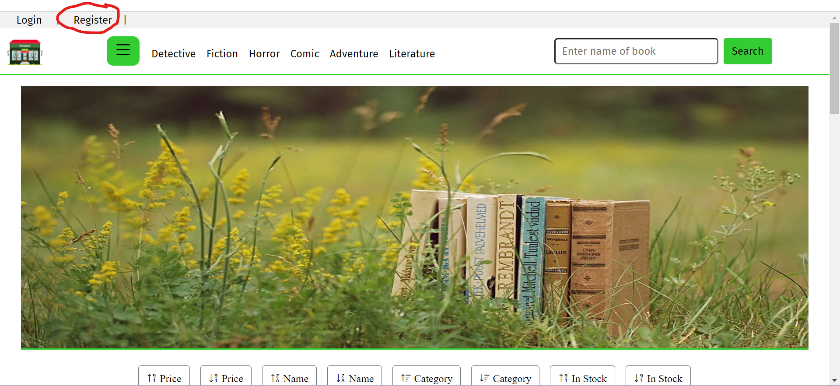

## 2.1. Register

If the user wants to register to the website, click “Register” as the red round above. After clicking, the page will be redirected to this page below. User has to enter some inputs, username and password must be at least 6 characters, email must be in the form of an email, or else an alert will be displayed. Then click the “Submit” button. Notes: user still have to login to do some special functions:

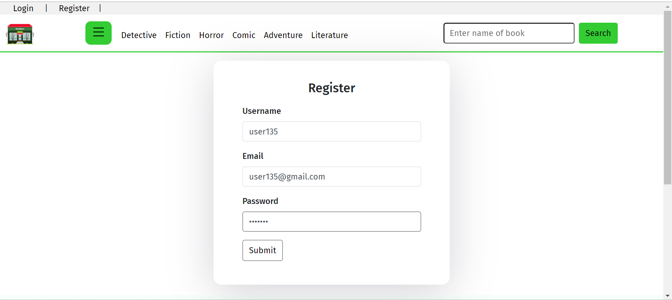

## 2.2. Search book

Enter keywords into the search box above then click the “Search” button. User only needs to enter a word in the name and keywords are set to be case insensitive.

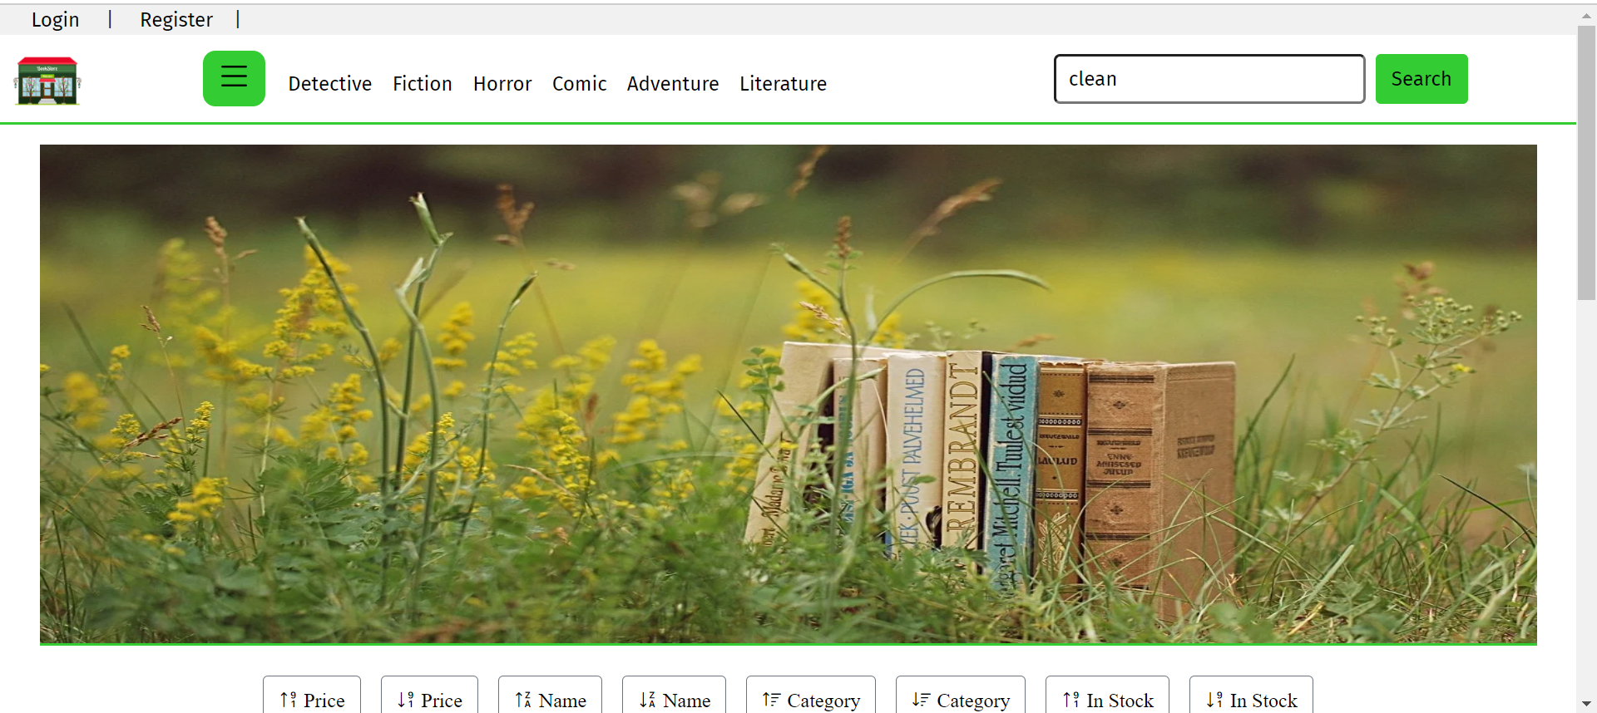

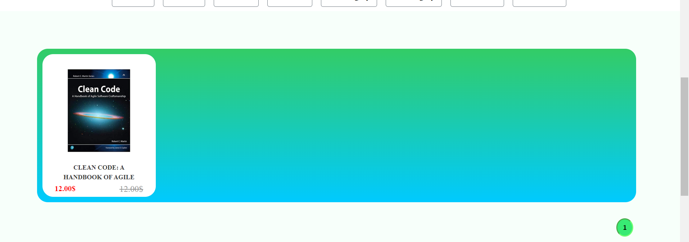

## 2.3. See books by category



Click any category on the menu bar to get books by category

## 2.4. Sort books

Click one of the type above to get all sorted books by that type



2.5. Get book details

Click a book out of the list displayed to return to details page:

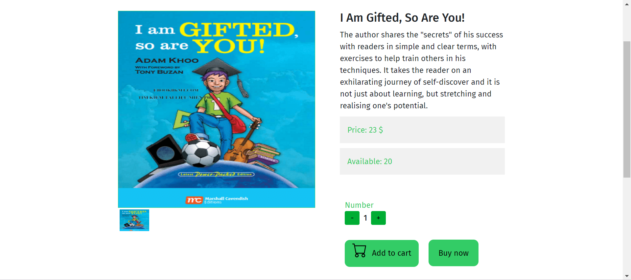

2.6. Return to home

Click the icon at the left top corner of the page:

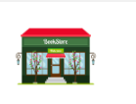

# 3. Customer (Registered user)

## 3.1. Login

Click “Login” at the top left corner of the page, right next to “Register”:



Enter enough and correct inputs then click “Submit” to login:

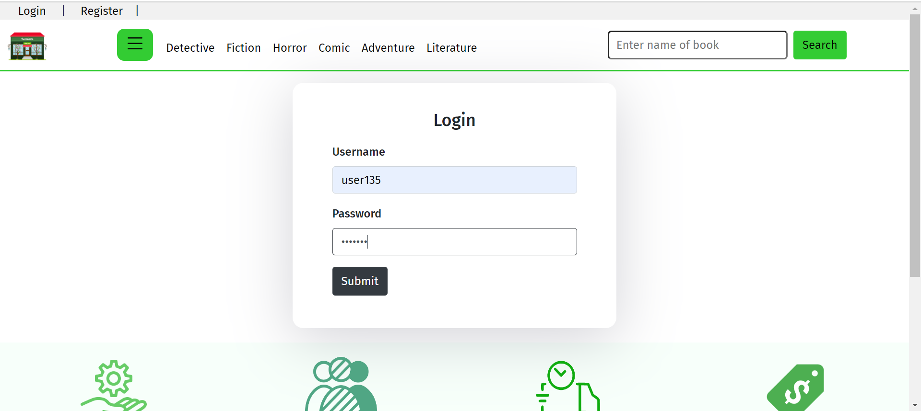

After logging in successfully, the page will direct to home page with a few new things:

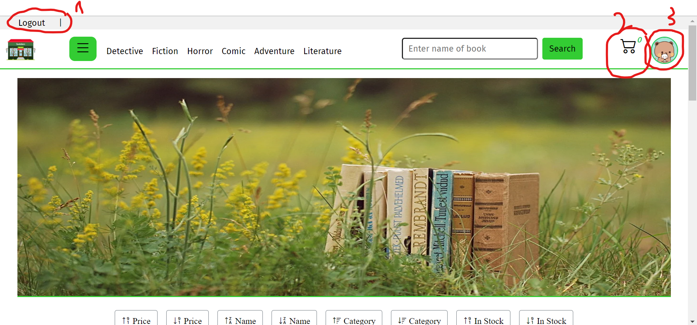

## 3.2. Logout

Click “Logout” as 1 on the picture above (3.1)

## 3.3. See shopping cart

Click the cart icon as 2 on the picture above (3.1) to redirect to the shopping cart. :

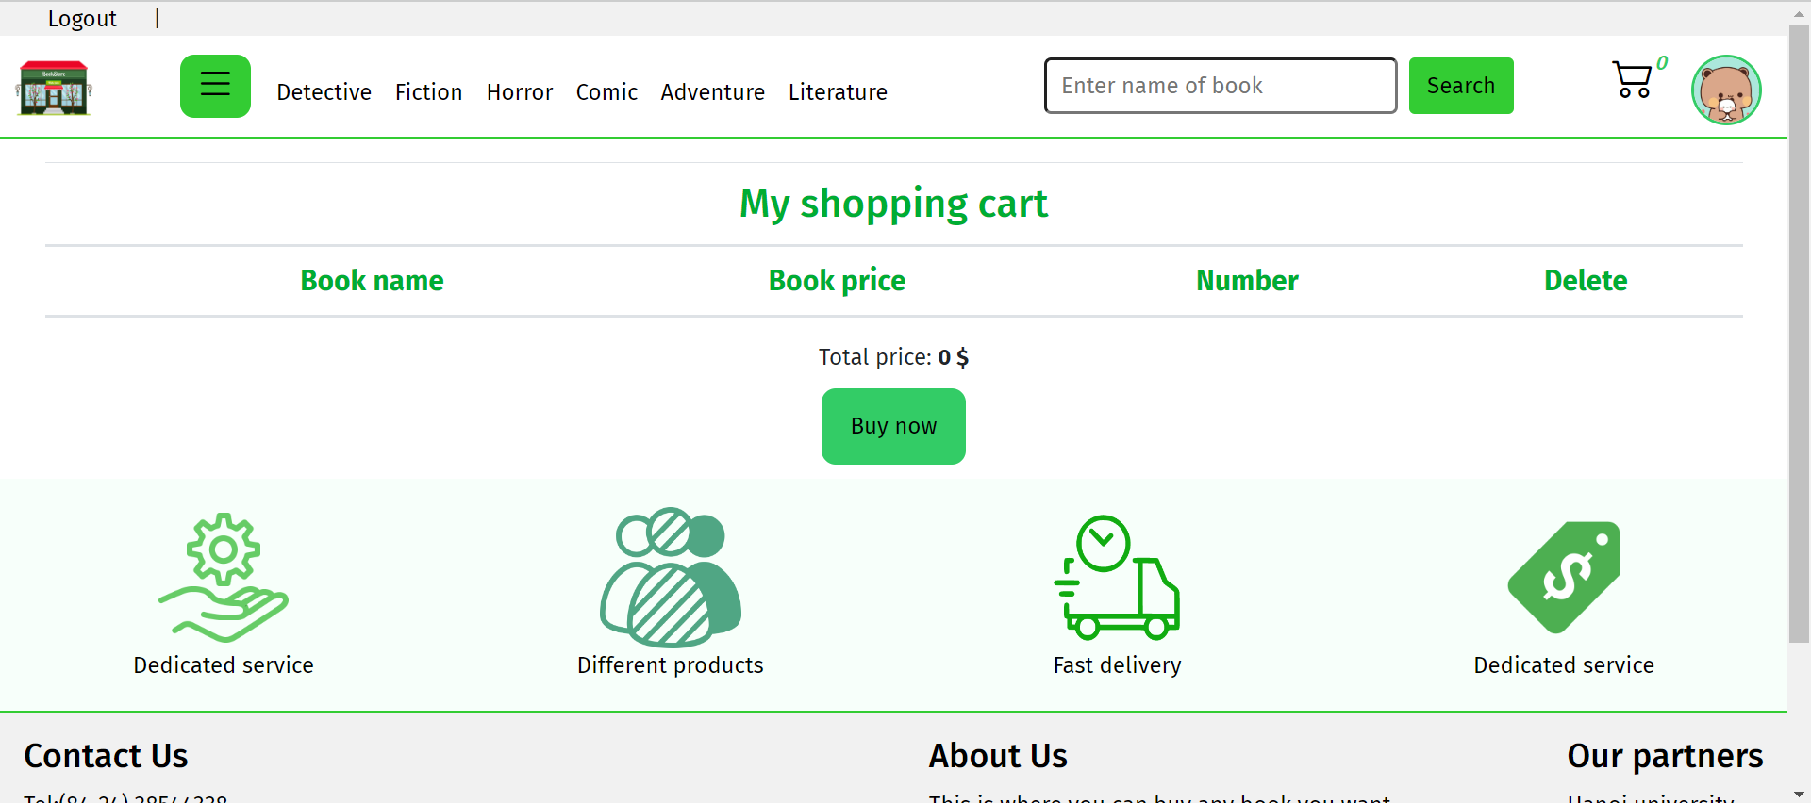

## 3.3. Update profile

Click the avatar icon as 3 on the picture above (3.1) to redirect to update profile page with a form:

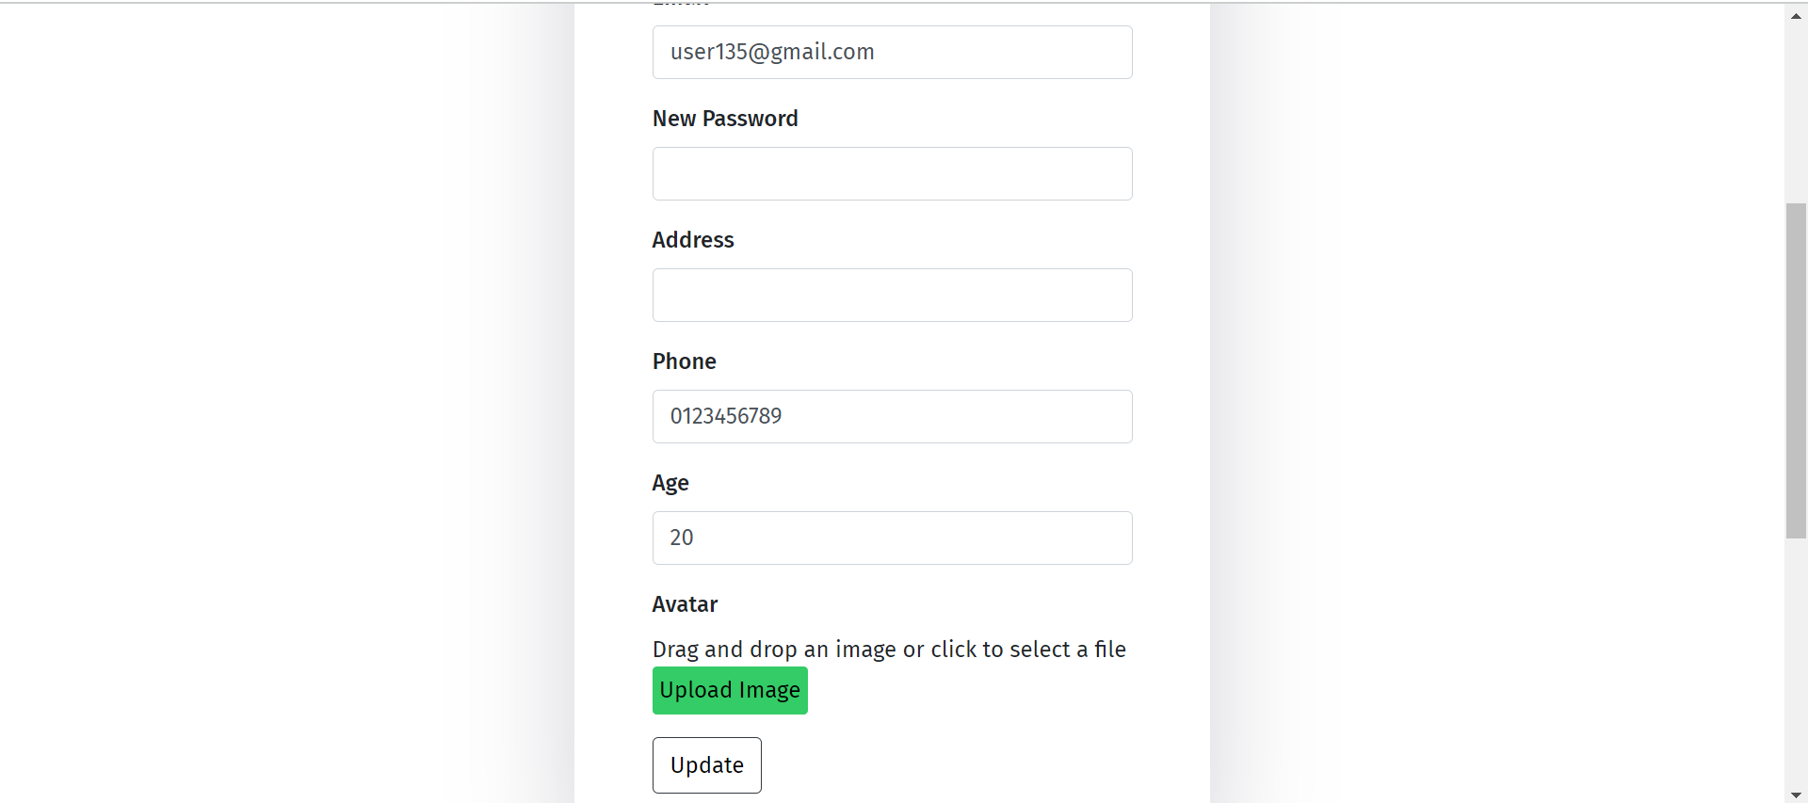

Enter enough information to update the profile by Clicking “Update” button

## 3.4. Add to cart

From book details, update quantity if needed, then click “Add to cart” button to add that item to shopping cart:

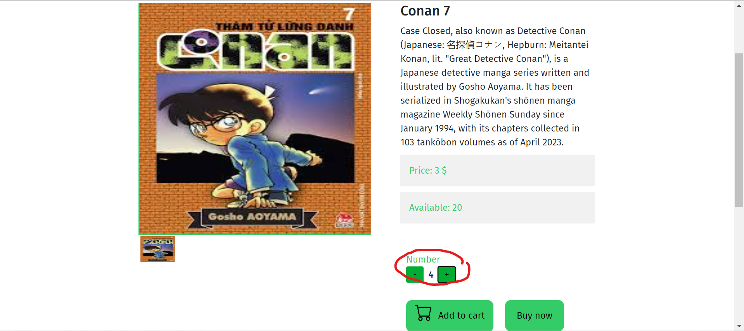

## 3.5. Buy now

### 3.5.1. Pay by cash

From book details or shopping cart, click “Buy now” button to redirect to checkout page:

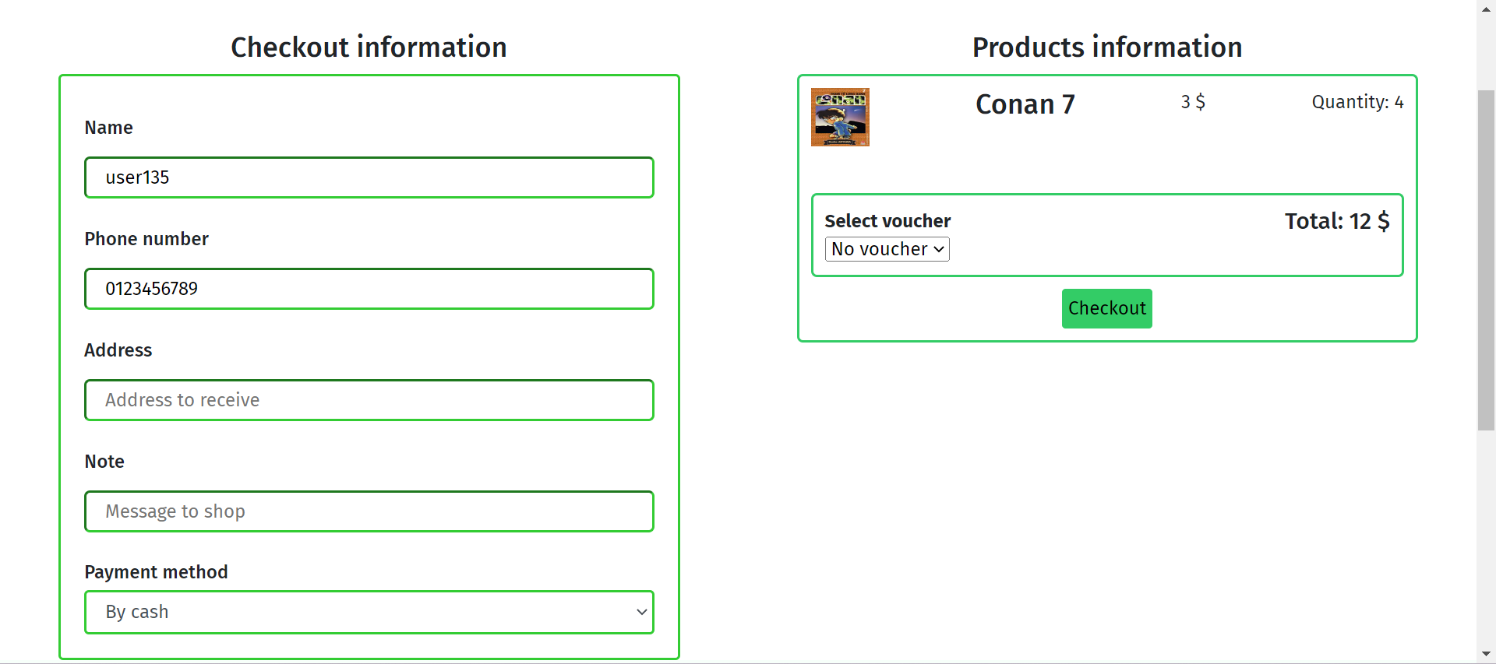

Enter necessary information then click “Checkout” button, the website will redirect to confirmation page:

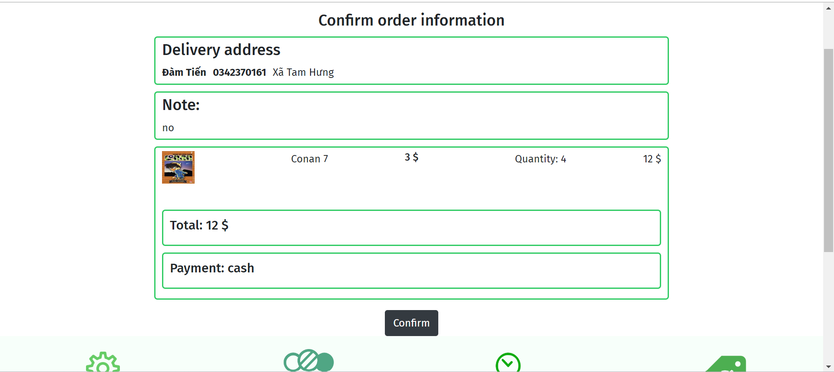

Click confirm button to confirm order, and get success message:

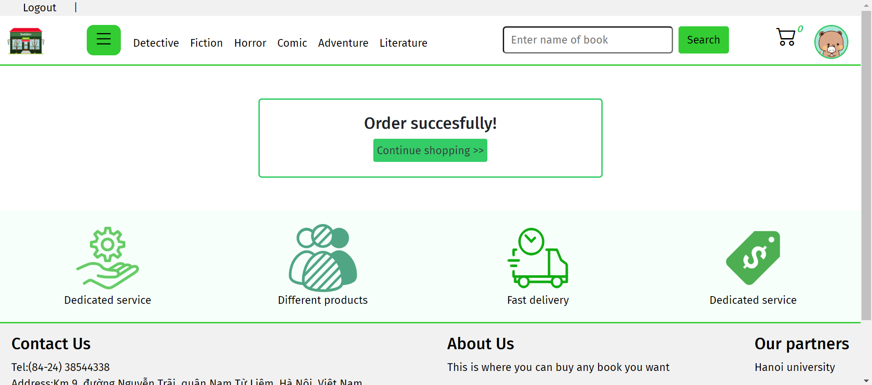

### 3.5.2. Pay online

Do the same as paying by cash, but after clicking “Confirm” button, the website will redirect to the paypal page

## 3.6. See orders by their status

Hover the mouse to the drop down icon, then click one of the status that you want to see orders:

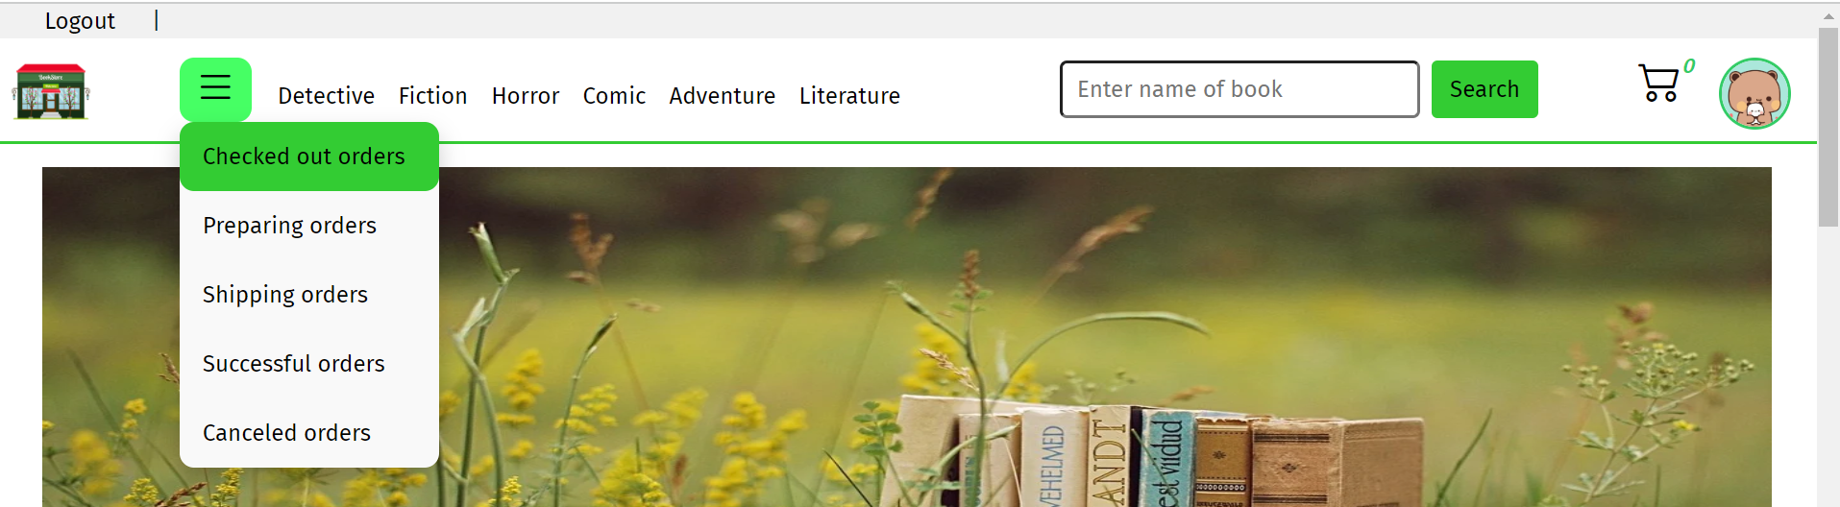

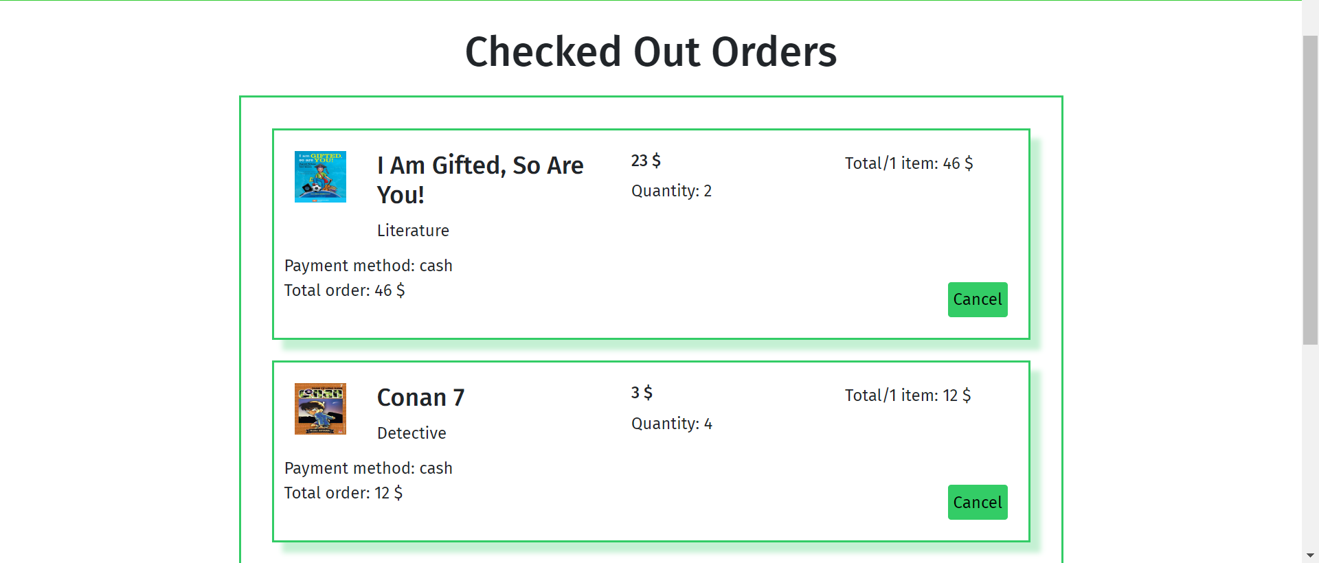

## 3.7. Change order status

Click button such as “Cancel” when the order is just checkout as above